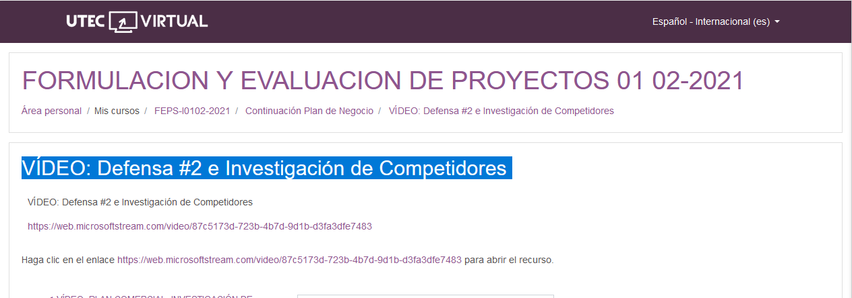

<https://web.microsoftstream.com/video/87c5173d-723b-4b7d-9d1b-d3fa3dfe7483>